LAMPIRAN

Lampiran 1. Pernyataan Persetujuan Menjadi Responden

PERNYATAAN PERSETUJUAN MENJADI RESPONDEN

Bahwa saya,
Nama :
Umur :
Jenis kelamin :
Berikanlah tanda () pada jawaban yang Anda pilih

- Apakah saat ini anda dalam kondisi sakit?
Ya, sakit apa..................................
Tidak
- Apakah anda ada alergi terhadap ikan?
Ya
Tidak

Dengan ini bersedia menjadi responden dalam penelitian yang dilakukan oleh Mahasiswa Politeknik Kesehatan Kemenkes Riau, yang bernama Badzlina Farahiyati JF dengan judul penelitian ‟Kadar Protein dan Sifat Organoleptik Lasagna Goreng dengan Substitusi Ikan Patin”.

Tertanda

Lampiran 2. Formulir Uji Hedonik

FORMULIR UJI HEDONIK

Nama Panelis :
Tanggal :
Jenis Produk : Lasagna Goreng dengan Substitusi Ikan Patin
Petunjuk :
- Disajikan 4 macam Lasagna Goreng dengan Substitusi Ikan Patin dengan kode sampel yang berbeda-beda. Sebelum melakukan uji organoleptik Lasagna Goreng dengan Substitusi Ikan Patin, kumur terlebih dahulu mulut anda dengan air yang telah disediakan dan lakukan secara berulang sebelum menilai sampel selanjutnya.
- Nyatakan penilaian anda terhadap rasa, warna, aroma, dan tekstur masing- masing sampel dengan memberikan tanda () pada kolom yang tersedia.
Aspek Penelitian | Skala Hedonik | Skala Numerik | Kode Sampel
 |  |  | P0 | P1 | P2 | P3
Warna | Sangat Suka | 5
 | Suka | 4
 | Agak Suka | 3
 | Tidak Suka | 2
 | Sangat Tidak Suka | 1
Aroma | Sangat Suka | 5
 | Suka | 4
 | Agak Suka | 3
 | Tidak Suka | 2
 | Sangat Tidak Suka | 1
Tekstur | Sangat Suka | 5
 | Suka | 4
 | Agak Suka | 3
 | Tidak Suka | 2
 | Sangat Tidak Suka | 1
Rasa | Sangat Suka | 5
 | Suka | 4
 | Agak Suka | 3
 | Tidak Suka | 2
 | Sangat Tidak Suka | 1
Lampiran 3. Hasil Uji Hedonik terhadap Rasa Lasagna Goreng Ikan Patin
Panelis | Perlakuan |  |  |  | Total
 | P0 (Kontrol) | P1 (30% daging ikan patin) | P2 (35% daging ikan patin) | P3 (40% daging ikan patin)
1 | 2 | 3 | 4 | 4 | 13
2 | 3 | 4 | 5 | 4 | 16
3 | 3 | 4 | 3 | 3 | 13
4 | 3 | 3 | 4 | 4 | 14
5 | 3 | 4 | 3 | 5 | 15
6 | 5 | 5 | 4 | 5 | 19
7 | 2 | 2 | 2 | 4 | 10
8 | 4 | 3 | 5 | 4 | 16
9 | 2 | 4 | 2 | 4 | 12
10 | 4 | 4 | 5 | 5 | 18
11 | 4 | 4 | 4 | 5 | 17
12 | 2 | 3 | 2 | 4 | 11
13 | 4 | 4 | 3 | 3 | 14
14 | 5 | 4 | 3 | 4 | 16
15 | 2 | 4 | 4 | 4 | 14
Jumlah | 48 | 55 | 53 | 62 | 218
Rata-Rata | 3,2 | 3,67 | 3,53 | 4,13 | 14,53

Lampiran 4. Hasil Analisis terhadap Rasa Lasagna Goreng Ikan Patin

Descriptives
Rasa
 | N | Mean | Std. Deviation | Std. Error | 95% Confidence Interval for Mean |  | Minimum | Maximum
 |  |  |  |  | Lower Bound | Upper Bound
P0 | 15 | 3.20 | 1.082 | .279 | 2.60 | 3.80 | 2 | 5
P1 | 15 | 3.67 | .724 | .187 | 3.27 | 4.07 | 2 | 5
P2 | 15 | 3.53 | 1.060 | .274 | 2.95 | 4.12 | 2 | 5
P3 | 15 | 4.13 | .640 | .165 | 3.78 | 4.49 | 3 | 5
Total | 60 | 3.63 | .938 | .121 | 3.39 | 3.88 | 2 | 5

ANOVA
Rasa
 | Sum of Squares | df | Mean Square | F | Sig.
Between Groups | 6.733 | 3 | 2.244 | 2.781 | .049
Within Groups | 45.200 | 56 | .807
Total | 51.933 | 59

Post Hoc Tests
Homogeneous Subsets

Rasa
Duncanª
Sampel | N | Subset for alpha = 0.05
 |  | 1 | 2
P0 | 15 | 3.20
P2 | 15 | 3.53 | 3.53
P1 | 15 | 3.67 | 3.67
P3 | 15 |  | 4.13
Sig. |  | .185 | .089

Lampiran 5. Hasil Uji Hedonik terhadap Warna Lasagna Goreng Ikan Patin

Panelis | Perlakuan |  |  |  | Total
 | P0 (Kontrol) | P1 (30% daging ikan patin) | P2 (35% daging ikan patin) | P3 (40% daging ikan patin)
1 | 3 | 4 | 3 | 2 | 12
2 | 2 | 3 | 4 | 5 | 14
3 | 3 | 3 | 3 | 3 | 12
4 | 1 | 1 | 4 | 3 | 9
5 | 2 | 2 | 5 | 2 | 11
6 | 2 | 2 | 3 | 4 | 11
7 | 4 | 2 | 4 | 3 | 13
8 | 2 | 3 | 2 | 4 | 11
9 | 1 | 5 | 5 | 5 | 16
10 | 3 | 2 | 2 | 1 | 8
11 | 5 | 3 | 5 | 5 | 18
12 | 4 | 4 | 4 | 4 | 16
13 | 3 | 2 | 2 | 2 | 9
14 | 1 | 4 | 4 | 2 | 11
15 | 2 | 5 | 5 | 5 | 17
Jumlah | 38 | 45 | 55 | 50 | 188
Rata-Rata | 2,53 | 3 | 3,67 | 3,33 | 12,53

Lampiran 6. Hasil Analisis terhadap Rasa Lasagna Goreng Ikan Patin

Descriptives
Warna
 | N | Mean | Std. Deviation | Std. Error | 95% Confidence Interval for Mean |  | Minimum | Maximum
 |  |  |  |  | Lower Bound | Upper Bound
P0 | 15 | 2.53 | 1.187 | .307 | 1.88 | 3.19 | 1 | 5
P1 | 15 | 3.00 | 1.195 | .309 | 2.34 | 3.66 | 1 | 5
P2 | 15 | 3.67 | 1.113 | .287 | 3.05 | 4.28 | 2 | 5
P3 | 15 | 3.33 | 1.345 | .347 | 2.59 | 4.08 | 1 | 5
Total | 60 | 3.13 | 1.255 | .162 | 2.81 | 3.46 | 1 | 5

ANOVA
Warna
 | Sum of Squares | df | Mean Square | F | Sig.
Between Groups | 10.533 | 3 | 3.511 | 2.386 | .079
Within Groups | 82.400 | 56 | 1.471
Total | 92.933 | 59

Lampiran 7. Hasil Uji Hedonik terhadap Tekstur Lasagna Goreng Ikan Patin

Panelis | Perlakuan |  |  |  | Total
 | P0 (Kontrol) | P1 (30% daging ikan patin) | P2 (35% daging ikan patin) | P3 (40% daging ikan patin)
1 | 4 | 4 | 3 | 3 | 14
2 | 4 | 3 | 4 | 3 | 14
3 | 4 | 3 | 4 | 3 | 14
4 | 5 | 4 | 3 | 2 | 14
5 | 5 | 3 | 3 | 3 | 14
6 | 3 | 5 | 3 | 3 | 14
7 | 4 | 3 | 4 | 2 | 13
8 | 4 | 4 | 2 | 3 | 13
9 | 4 | 5 | 2 | 3 | 14
10 | 4 | 4 | 2 | 4 | 14
11 | 4 | 4 | 5 | 5 | 18
12 | 4 | 4 | 5 | 4 | 17
13 | 3 | 3 | 3 | 3 | 12
14 | 4 | 2 | 3 | 3 | 12
15 | 5 | 1 | 4 | 3 | 13
Jumlah | 61 | 52 | 50 | 47 | 210
Rata-Rata | 4,07 | 3,47 | 3,33 | 3,2 | 14

Lampiran 8. Hasil Analisis terhadap Tekstur Lasagna Goreng Ikan Patin

Descriptives
Tekstur
 | N | Mean | Std. Deviation | Std. Error | 95% Confidence Interval for Mean |  | Minimum | Maximum
 |  |  |  |  | Lower Bound | Upper Bound
P0 | 15 | 4.07 | .594 | .153 | 3.74 | 4.40 | 3 | 5
P1 | 15 | 3.47 | 1.060 | .274 | 2.88 | 4.05 | 1 | 5
P2 | 15 | 3.33 | .976 | .252 | 2.79 | 3.87 | 2 | 5
P3 | 15 | 3.20 | .775 | .200 | 2.77 | 3.63 | 2 | 5
Total | 60 | 3.52 | .911 | .118 | 3.28 | 3.75 | 1 | 5

ANOVA
Tekstur
 | Sum of Squares | df | Mean Square | F | Sig.
Between Groups | 6.583 | 3 | 2.194 | 2.898 | .043
Within Groups | 42.400 | 56 | .757
Total | 48.983 | 59

Post Hoc Tests
Homogeneous Subsets

Tekstur
Duncanª
Sampel | N | Subset for alpha = 0.05
 |  | 1 | 2
P3 | 15 | 3.20
P2 | 15 | 3.33
P1 | 15 | 3.47 | 3.47
P0 | 15 |  | 4.07
Sig. |  | .435 | .064

Lampiran 9. Hasil Uji Hedonik terhadap Aroma Lasagna Goreng Ikan Patin

Panelis | Perlakuan |  |  |  | Total
 | P0 (Kontrol) | P1 (30% daging ikan patin) | P2 (35% daging ikan patin) | P3 (40% daging ikan patin)
1 | 5 | 5 | 4 | 5 | 19
2 | 1 | 4 | 4 | 5 | 14
3 | 4 | 3 | 3 | 3 | 16
4 | 3 | 3 | 5 | 4 | 15
5 | 4 | 2 | 5 | 4 | 15
6 | 3 | 5 | 2 | 3 | 13
7 | 2 | 2 | 4 | 4 | 12
8 | 3 | 3 | 3 | 3 | 12
9 | 1 | 4 | 4 | 5 | 14
10 | 3 | 2 | 5 | 2 | 12
11 | 5 | 4 | 5 | 4 | 18
12 | 2 | 2 | 2 | 4 | 10
13 | 2 | 2 | 2 | 5 | 11
14 | 3 | 3 | 4 | 2 | 12
15 | 2 | 1 | 4 | 5 | 12
Jumlah | 43 | 45 | 56 | 58 | 205
Rata-Rata | 2,87 | 3 | 3,73 | 3,87 | 13,67

Lampiran 10. Hasil Analisis terhadap Aroma Lasagna Goreng Ikan Patin

Descriptives
Aroma
 | N | Mean | Std. Deviation | Std. Error | 95% Confidence Interval for Mean |  | Minimum | Maximum
 |  |  |  |  | Lower Bound | Upper Bound
P0 | 15 | 2.87 | 1.246 | .322 | 2.18 | 3.56 | 1 | 5
P1 | 15 | 3.00 | 1.195 | .309 | 2.34 | 3.66 | 1 | 5
P2 | 15 | 3.73 | 1.100 | .284 | 3.12 | 4.34 | 2 | 5
P3 | 15 | 3.87 | 1.060 | .274 | 3.28 | 4.45 | 2 | 5
Total | 60 | 3.37 | 1.207 | .156 | 3.05 | 3.68 | 1 | 5

ANOVA
Aroma
 | Sum of Squares | df | Mean Square | F | Sig.
Between Groups | 11.533 | 3 | 3.844 | 2.894 | .043
Within Groups | 74.400 | 56 | 1.329
Total | 85.933 | 59

Aroma
Duncanª
Sampel | N | Subset for alpha = 0.05
 |  | 1 | 2
P0 | 15 | 2.87
P1 | 15 | 3.00 | 3.00
P2 | 15 | 3.73 | 3.73
P3 | 15 |  | 3.87
Sig. |  | .055 | .055

Lampiran 11. Hasil Uji Kadar Protein Lasagna Goreng Ikan Patin
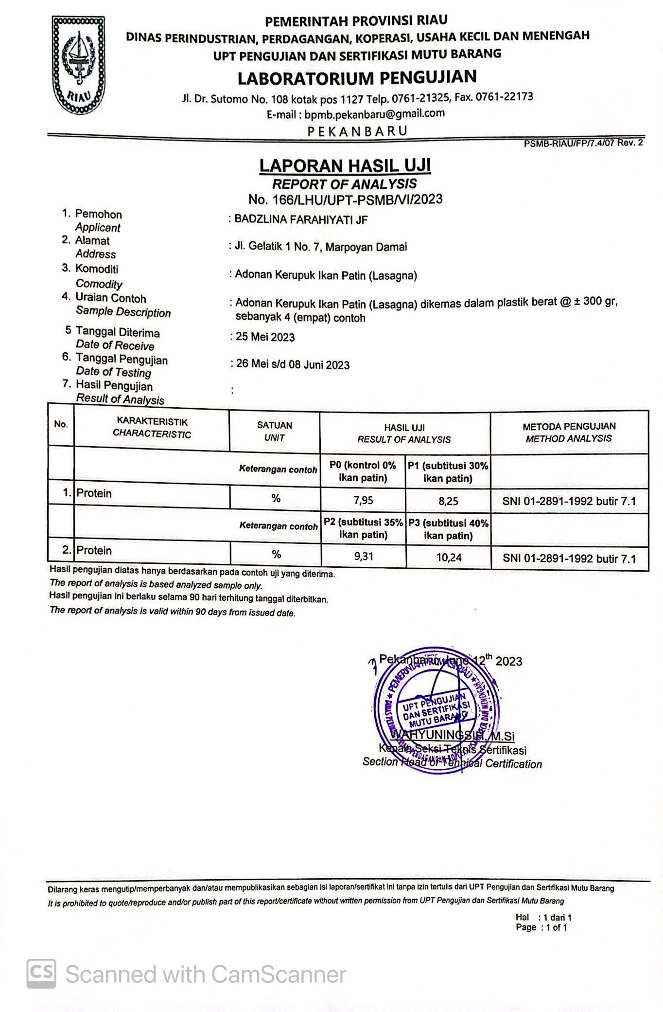

Lampiran 12. Dokumentasi

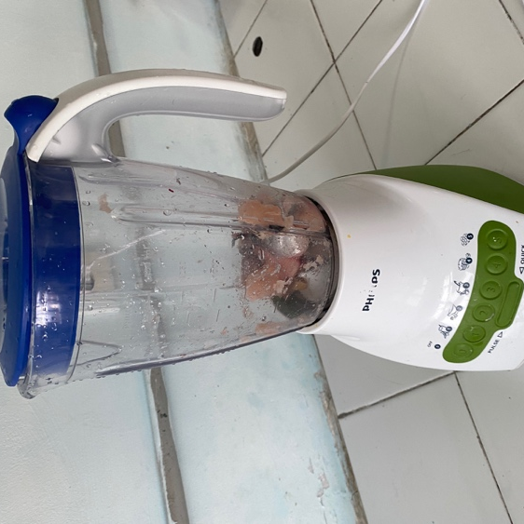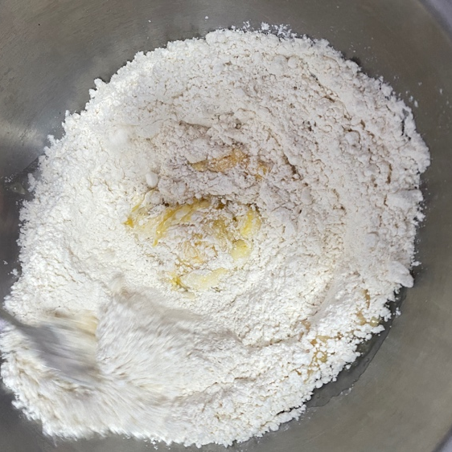
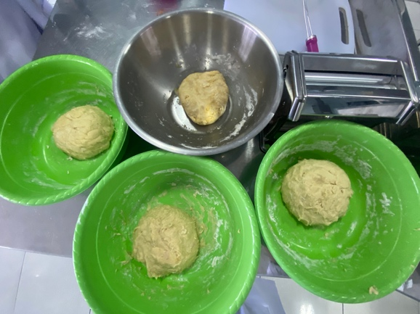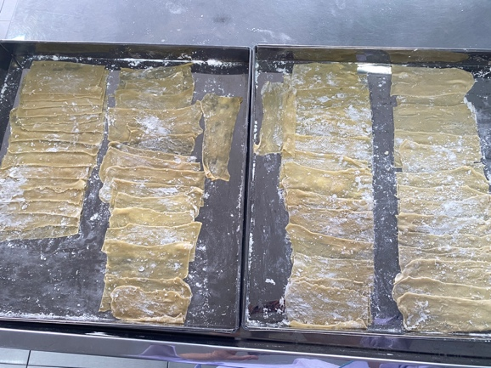
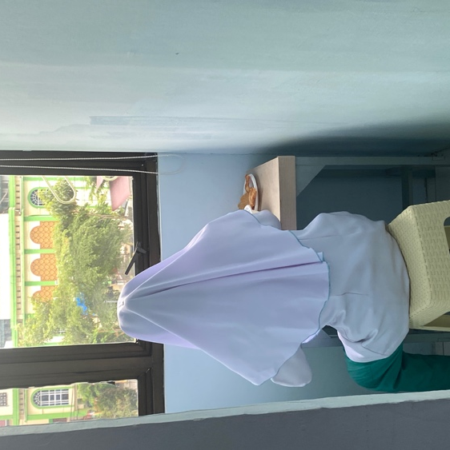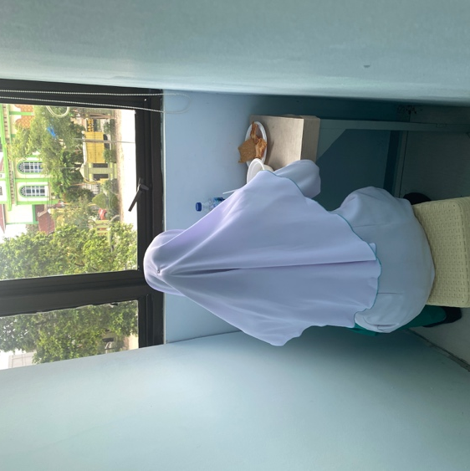

Lampiran 13. Surat Izin Penelitian Kampus Poltekkes Kemenkes Riau

